RADIOLAB Podcast Yellow Fluff and Other Curious Encounters Homework Assignment

Name: __________________________________________

Listen to the periodic table segment of the Radiolab Podcast “Yellow Fluff and Other Curious Encounters” Click on link to access podcast. You must have internet access to do this. Then completely answer all questions below. Your grade will be based on how complete and correct your answers are.

Podcast URL: http://www.radiolab.org/story/91672-yellow-fluff-and-other-curious-encounters

- What was inside Dr. Oliver Sacks fine wooden box?

- What four “elements” did ancient people originally believe existed?

- Who was Dmitri Mendeleev?

- What was Mendeleev trying to understand by playing with his nerdy cards?

- THINKING CAP QUESTION! Which of the main-group elements in the periodic table (not transition metals) would you expect to be least reactive (or most “shy”)? Which main-group elements in the periodic table would you expect to be most reactive (or most “friendly”)? What is the difference in the atomic structure of “shy” vs. “friendly” element?
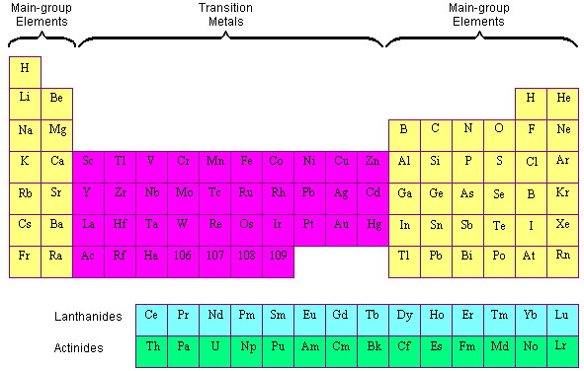

- Find a detailed periodic table in a textbook or on-line and look at the atomic number of each element. The atomic number informs us about the size of the element. What do you notice about the order of the elements in the periodic table with respect to size?

- So elements range from relatively “small” to “large” and from “shy” to “friendly.” Based on these characteristics, which element would best represent you? Explain why.

- They close the Periodic Table segment of the podcast with a question, “Is the periodic table is a discovery or an invention?” What does that mean? What do you think (discovery or invention), and why?

- Summarize the story of scientist Jerry Coyne and his pet botfly.

- Tom Eisner, the entomologist (bug scientist), has some crazy dreams. What does he dream about?

