Molecular Genetics - Transcription and Translation Homework Assignment

Name: _____________________________________________

1. Completely define genetic:
Transcription –

Translation –

2. Below is a picture of DNA “unzipping” and going through transcription. Show the resulting RNA molecule by writing in the appropriate complementary base pairs along the top DNA strand, within the replication fork depicted.

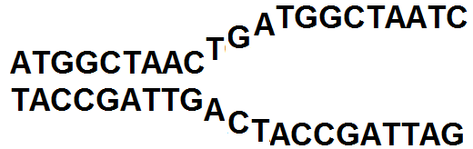

3. You will now practice transcribing and translating the genetic code into chains of amino acids (proteins). First transcribe the DNA sequence into mRNA. Then use the wheel on the next page to translate each mRNA codon into the appropriate sequenced of amino acids. See the following example:

EXAMPLE PROBLEM: The example below will show you how to solve the two problems on the next page.

Transcribe & translate the following DNA sequence:
TACAATTGGCTTCTGTGTAGGTATACCTATGATTAG < DNA

How to Solve –
- Divide the DNA sequence into triplets (It can be useful to number each codon and amino acid, to help prevent you from getting lost in the code):

1 2 3 4 5 6 7 8 9 10 11 12
TAC-GAC-CGU-TGG-CTT-CTG-TGT-AGG-TAT-ACC-GAT-ACT < DNA

- Transcribe into mRNA.:
1 2 3 4 5 6 7 8 9 10 11 12
AUG-CUG-GCA-ACC-GAA-GAC-ACA-UCC-AUA-UGG-CUA-UGA < mRNA

- To build your protein, determine the amino acid that each mRNA codons codes for, based on the protein synthesis wheel on the next page.

1 2 3 4 5 6 7 8 9
Methionine (START) – Leucine –Alanine – Threonine - Glutamic Acid - Aspartic Acid – Threonine – Serine - Isoleucine-
10 11 12
Tryptophan – Leucine - STOP < Protein
*Note that the amino acid Theronine occurs twice in this protein. Was it coded for each time by the exact same codon or not?
Transcribe and translate the following two sequences yourself, based on the previous example:

a. TACGACGTATAGATGACAGGTAGATGTTTCAGGGGGATATAAATT

b. TACGCCATAGAGTGTCAAAAGTCTCAAACT

Protein Synthesis Wheel
Shows which amino acid each mRNA codon codes for.
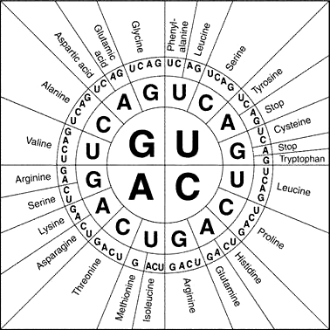
START = Start Signal: AUG (Methionine)
STOP = Termination Signals UAG , UAA, UGA

