RADIOLAB Podcast “Parasites” Homework Assignment

Name: __________________________________________

Listen to the “Parasites” Radiolab Podcast (Control + click on link to access podcast or go to http://www.radiolab.org/story/91689-parasites) Then answer the following questions. Your grade will be based on how complete and correct your answers are.

- What scene from what movie do they start this podcast with? Why do you think they featured this scene?

- PARASITE 1: Describe the life cycle of the Parasitic Wasp featured. What is its host? What is so crazy amazing about how it uses its host? Why do they refer to this wasp as doing “brain surgery”? Why did they refer to its host as a “zombie”?

- PARASITE 2: Describe the life cycle of the Parasitic Nematode featured. What is the advantage of its making an infected ant’s butt big and bright red?

- PARASITE 3: Describe the life cycle of the Blood Fluke featured. How and why do the male and female blood fluke differ in their appearance? Why did Dr. Zimmer refer to blood flukes as a good example of “family values”?

- PARASITE 4: Describe the life cycle of the Human Hookworm featured. How was John D. Rockefeller and southern US commerce involved in the story? How far away from a pile of poop can hookworms crawl before dying? How did Rockefeller’s medical investigators eradicate the hookworm problem, as well as many other excrement-related parasitic diseases?

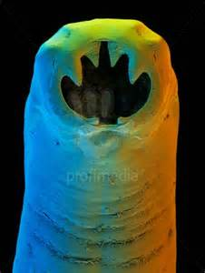

- What were Jasper Lawrence’s debilitating health problems? How did he solve them? Jasper used to have a lawn care business. What business is he in now? (Please answer questions 6 & 7 in detail in order to earn all points.)

- What is the Hygiene Hypothesis and how do scientists think it relates to how Jasper’s hookworms are “fixing” his immune system? How does this relate to co-evolution? What other disorders do they think can be helped by hookworm infection?

- PARASITE 5: Describe the lifecycle of Toxoplasma gondii. Where does Toxoplama “want” to be? How does Toxo get into rats and deal with the problem of being stuck in the wrong host animal?

- How do scientists think Toxo might be able to affect human brain function and behavior?

- Do you think parasites are “degenerates”? Please support your answer.

